**Allopathic Madicine**

**List of Top 10 Medicines for Fever**

Paracetamol

Paracetamol Syrup

Children’s Ibuprofen

Advil Capsule

Bayer’s Chewable Baby Aspirin

Aspirin For Adults(325 mg coated tablets)

Voltaren

Dolo

Benylin

Panadol

**List of Top 10 Medicines for Stomacache**

[Simethicone: Cures stomach ache due to gas in the stomach](https://cashkaro.com/blog/best-medicines-for-stomach-ache-composition-dosage-popularity-and-more/91630#1-Simethicone-Cures-stomach-ache-due-to-gas-in-the-stomach)

[Antacid: Cures stomach ache due to hyperacidity](https://cashkaro.com/blog/best-medicines-for-stomach-ache-composition-dosage-popularity-and-more/91630#2nbspAntacid-Cures-stomach-ache-due-to-hyperacidity)

[Famotidine: Cures stomach ache due to hyperacidity](https://cashkaro.com/blog/best-medicines-for-stomach-ache-composition-dosage-popularity-and-more/91630#3nbspFamotidine-Cures-stomach-ache-due-to-hyperacidity)

[Ranitidine: Cures stomach ache due to hyperacidity](https://cashkaro.com/blog/best-medicines-for-stomach-ache-composition-dosage-popularity-and-more/91630#4nbspRanitidine-Cures-stomach-ache-due-to-hyperacidity)

[Docusates: Cures stomach ache due to constipation](https://cashkaro.com/blog/best-medicines-for-stomach-ache-composition-dosage-popularity-and-more/91630#5nbspDocusates-Cures-stomach-ache-due-to-constipation)

[Bisacodyl: Cures stomach ache due to severe constipation](https://cashkaro.com/blog/best-medicines-for-stomach-ache-composition-dosage-popularity-and-more/91630#6nbspBisacodyl-Cures-stomach-ache-due-to-severe-constipation)

[Bismuth: Cures cramping in the stomach due to diarrhoea](https://cashkaro.com/blog/best-medicines-for-stomach-ache-composition-dosage-popularity-and-more/91630#8nbspBismuth-Cures-cramping-in-the-stomach-due-to-diarrhoea)

[Aleve: Cures stomach ache](https://cashkaro.com/blog/best-medicines-for-stomach-ache-composition-dosage-popularity-and-more/91630#9nbspAleve-Cures-stomach-ache)

[Promethazine theolate: Prevents stomach ache due to nausea and vomiting](https://cashkaro.com/blog/best-medicines-for-stomach-ache-composition-dosage-popularity-and-more/91630#10-Promethazinenbsptheolate-Prevents-stomach-ache-due-to-nausea-and-vomiting)

[Lactaid: Cures gas,  bloating and mild lactose intolerance](https://cashkaro.com/blog/best-medicines-for-stomach-ache-composition-dosage-popularity-and-more/91630#11nbspLactaid-Cures-gasnbsp-bloating-and-mild-lactose-intolerance)

[Dipep: Cures stomach ache due to indigestion](https://cashkaro.com/blog/best-medicines-for-stomach-ache-composition-dosage-popularity-and-more/91630#12nbspDipep-Cures-stomach-ache-due-to-indigestion)

[Ashokarishta: Cures stomach ache due to menstrual cramps](https://cashkaro.com/blog/best-medicines-for-stomach-ache-composition-dosage-popularity-and-more/91630#13nbspAshokarishta-Cures-stomach-ache-due-to-menstrual-cramps)

[Zandu Pancharishta: Cures stomach ache](https://cashkaro.com/blog/best-medicines-for-stomach-ache-composition-dosage-popularity-and-more/91630#14-Zandu-Pancharishta-Cures-stomach-ache)

[Haslab Digesto Syrup: Cures stomach ache](https://cashkaro.com/blog/best-medicines-for-stomach-ache-composition-dosage-popularity-and-more/91630#15nbspHaslab-Digesto-Syrup-Cures-stomach-ache)

* **List of Top 10 Medicines for Sneezing**

### [Acrivastine and Pseudoephedrine](https://www.medindia.net/doctors/drug_information/acrivastine_pseudoephedrine.htm)

### [Astemizole](https://www.medindia.net/doctors/drug_information/astemizole.htm)

### [Brompheniramine](https://www.medindia.net/doctors/drug_information/brompheniramine.htm)

### [Chlorpheniramine](https://www.medindia.net/doctors/drug_information/chlorpheniramine.htm)

### [Clemastine](https://www.medindia.net/doctors/drug_information/clemastine.htm)

**List of Top 20 Medicines for a Toothache**

Acuvin

Alfam

Alrof

Cedo Plus

Centrivon

Clenora-MP

Clindamycin

Clove oil

Dart

Duralgina Suppository

Gredol

Metamizole

Metronidazole

Naproxen

Nuprin

Parvon

Propyphenazone

Tylenol 3

Vicodin

Winmol

**List of Top 20 Medicines for Mouth Ulcer**

Anabel Liquid

Curasil

Dentogel

Dologel-CT

Emergel

Fitgel

Hexigel

Garbenz

Lexanox Plus

Mamdew Baby

Mugel Freshora

Omnisoothe

Orafast

Oraflora LA

Orawin

Tantum

Tess CS

Ulciwok

Viloral

Zytee RB

**Medicines for Jaw pain**

**Tylenol (acetaminophen)**

**Advil or Motrin (ibuprofen)**

**Aleve (naproxen)**

**Ecotrin (aspirin)**

**Medications for type 1 diabetes**

### Insulin

### Amylinomimetic drug

**Medications for type 2 diabetes**

### Alpha-glucosidase inhibitors

### Biguanides

### Dopamine agonist

### Dipeptidyl peptidase-4 (DPP-4) inhibitors

### Glucagon-like peptide-1 receptor agonists (GLP-1 receptor agonists)

### Meglitinides

### Sodium-glucose transporter (SGLT) 2 inhibitors

### Sulfonylureas

### Thiazolidinediones

**Drugs for Asthma**

Acebrophylline. ...

Acetylcysteine. ...

Albuterol (Salbutamol) ...

Bambuterol. ...

Beclomethasone. ...

Bromhexine. ...

Budesonide. ...

Budesonide and Formoterol.

**Hair loss treatment for men and women**

**Minoxidil**

**Finasteride**

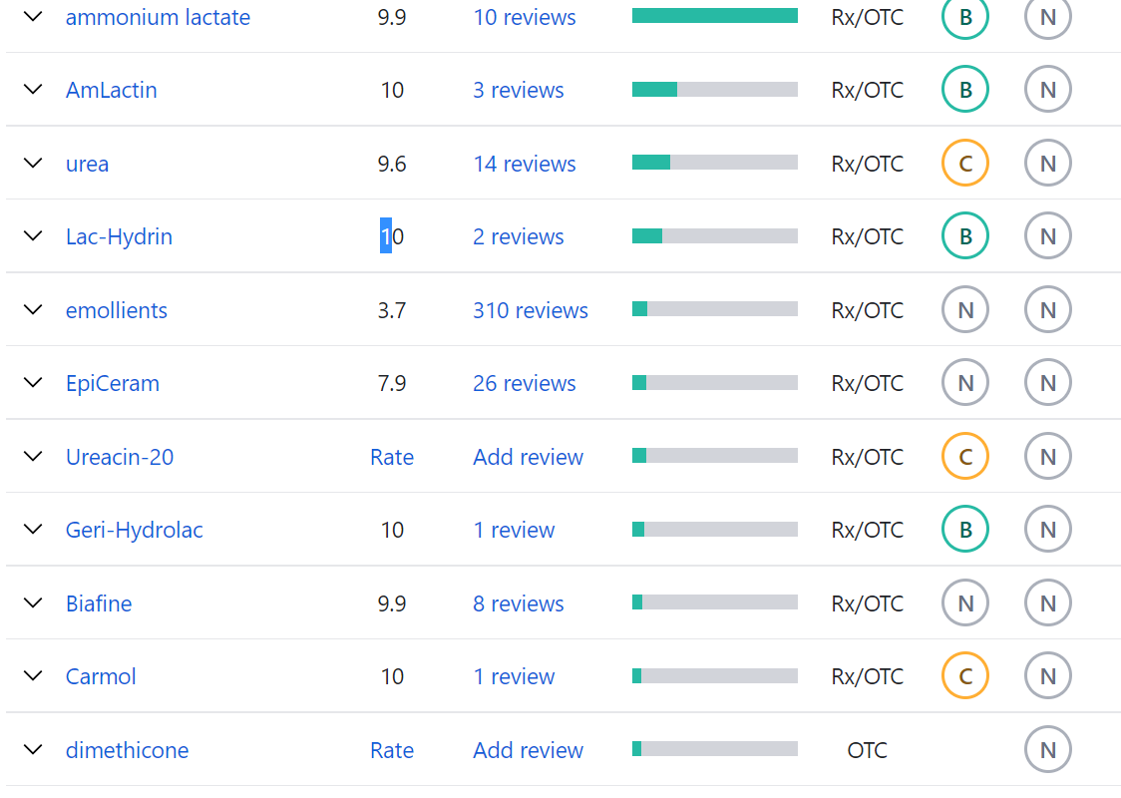

**Drugs for Itchy Skin**

Cetirizine. Cetirizine is an antihistamine, prescribed for allergic reactions. ...

Fluoxetine. Fluoxetine is an antidepressant, prescribed for depression and anxiety. ...

Gabapentin. Gabapentin is an anticonvulsant, prescribed for postherpetic neuralgia, and epilepsy. ...

Hydrocortisone. ...

Piperazine. ...

Tacrolimus.

**Red eye**

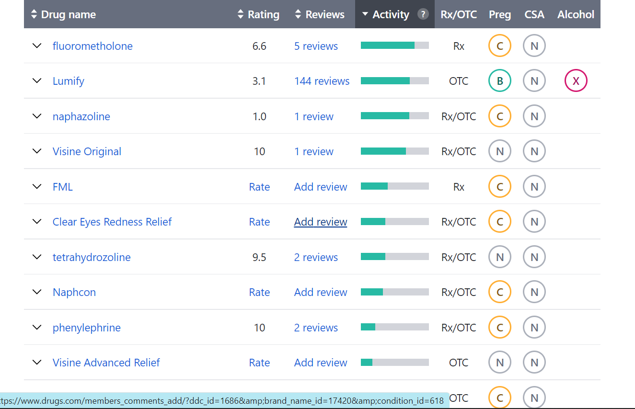

## What are the best over-the-counter (OTC) medications for itchy eyes?

### Saline eye drops

### Oral antihistamines

### Antihistamine eye drops

### Antihistamine eye drops

### Decongestant eye drops

**Watery eye**

### [Acrivastine](https://www.medindia.net/doctors/drug_information/acrivastine.htm)

### [Acrivastine and Pseudoephedrine](https://www.medindia.net/doctors/drug_information/acrivastine_pseudoephedrine.htm)

### [Lofexidine](https://www.medindia.net/doctors/drug_information/lofexidine.htm)

**Depression**

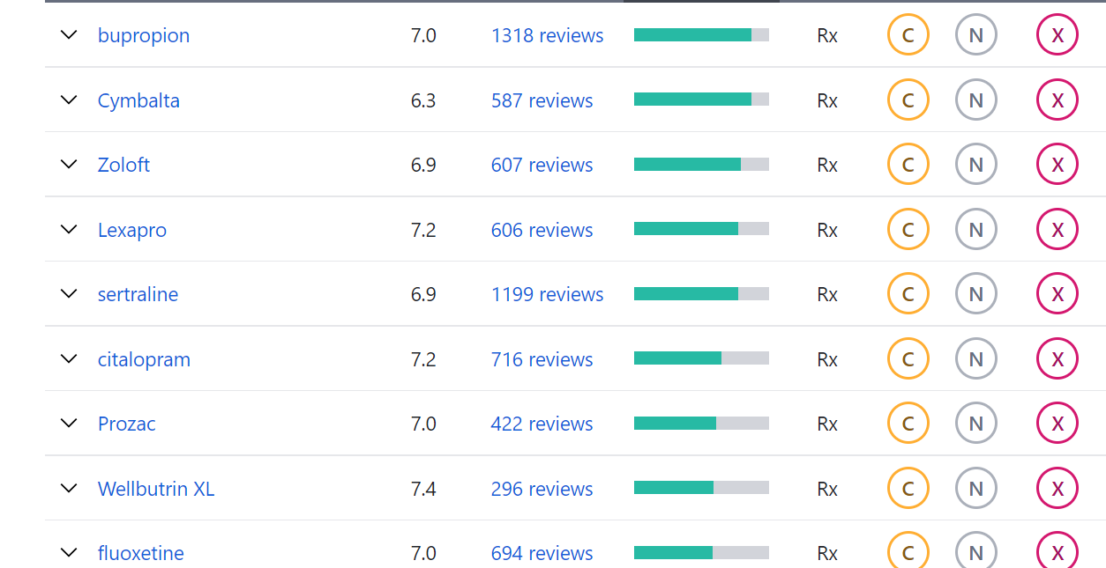

**What are some examples of anxiety medications?**

Citalopram (Celexa)

Escitalopram (Lexapro)

Fluvoxamine (Luvox)

Paroxetine (Paxil)

Fluoxetine (Prozac)

Sertraline (Zoloft)

Vilazodone (Viibryd)

Vortioxetine (Trintellix)